Rushcliffe Labour Party Proposed Changes to the New electoral arrangements for Rushcliffe Council Draft Recommendations October 2021
Content
- South Western West Bridgford & North Eastern West Bridgford Proposals
- South Western Rushcliffe Proposals
- South Eastern Rushcliffe Proposals
- Northern and Central Rushcliffe Proposals

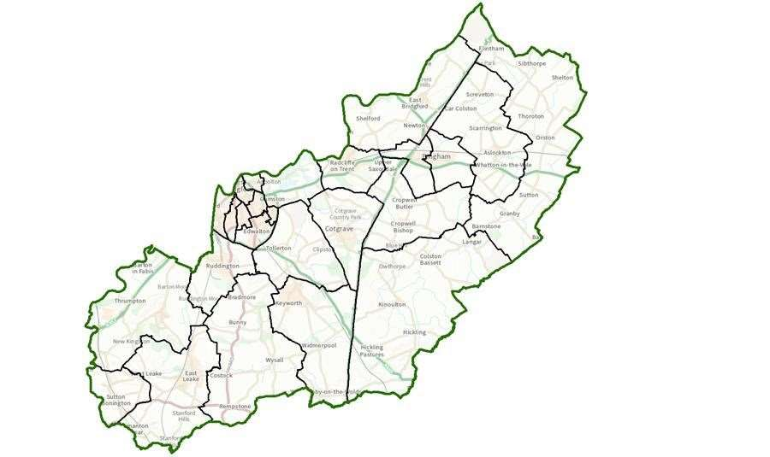
South Western West Bridgford & North Eastern West Bridgford Proposals

In general we believe that the electors are best served by single councillor wards and that multi councillor wards increasingly disenfranchise some electors the larger the wards get. For example, It is not uncommon for multi-councillor wards to return multiple councillors from the same party, when in fact a significant number of electors in that ward may well have returned a different councillor if they voted in a single councillor wards. In addition the larger a ward is the more likely it is to include significantly different communities who may then feel they are not properly represented by their councillors. Therefore, the creation of the two new three councillor wards in West Bridgford may well disenfranchise a significant number of electors, for the reasons stated previously, and should be rejected in favour of single and at most two councillor wards.
Therefore we propose
- Split Compton Acres as defined in the Commission’s recommendations into two single councillor wards along Rugby Road/ Acorn Gardens. The northern part of the proposed ward is predominately the part of the ward running either side of Wilford Lane (including the Rivermead flats). There is a strong case for those properties (due to the age and style of the properties along with their community links) to have separate representation from Compton acres which dates from the 1980s. Looking at the existing polling wards, that would make CAB1 and CAB2 one (the northern ward) and CAB3 as the other. This would leave wards of size 2009 and 2229 based on the predicted electors in 2027. This compromise better serves, overall, the existing electorate.
- Split Edwalton (as proposed by the commission) into two single councillor wards along the old railway (part of which is footpath and part private land) which currently runs through alongside the east side of Rushcliffe school, continues over Melton Road and alongside the golf course. This is a natural barrier between (most of) old Edwalton and the new housing on either side of the Melton Road. The new housing does not look to old Edwalton village for services as they have Aldi, Costa Coffee, other shops and a new Primary school on their doorstep so there is no reason for them to go into Edwalton village. The old village already has it's own school, shops (store, post office, cafe) at the junction of Wellin Lane and Earlswood drive. Additionally, the planned pedestrian access from the new estate to Musters Road would make it less likely that residents of the new estate would use Edwalton village for services as many would be better served by shops on Boundary Road in Musters Ward. So old and new parts of Edwalton will be distinct communities making it even more logical for there to be two single councillor wards as opposed to a single two councillor ward.
- Whilst Gamston parish council favours a two-councillor ward, there is simple delineation along the existing boundary between Gamston North and South with electors of 1892 and 1932 respectively which would preserve one councillor wards and reflects current boundary excepting the Commission’s proposed alterations.

This leaves the more northern part of West Bridgford with the additional need to reduce number of councillors by one to meet the commission’s overall target of 2400 electors per councillor. Currently we have
Ward | Councillors | Current Electors | Forecast Electors (2027)
Abbey | 2 | 4552 | 4605
Lady Bay | 2 | 3913 | 3992
Lutterell | 2 | 4292 | 4438
Musters | 2 | 3553 | 3732
Trent Bridge | 2 | 4472 | 4768

The Commission’s solution is to reduce Lutterell to a one councillor ward, merge Lady Bay, Trent Bridge and Abbey together to create two three councillor wards and increase size of Musters to increase number of electors toward desired average for a two-councillor ward.
As previously stated, three councillor wards will reduce democratic accountability considerably. The proposed new boundaries also preserve some anomalies in terms of community identity in Musters ward and lumps dissimilar areas of West Bridgford from existing Trent Bridge and Lady Bay wards together.
In our view it would make sense to generally keep the existing wards as far as we are able and preserve them either as one or two councillor wards. Given the existing situation that they are all two councillor wards it is easier to work with these existing wards than try to create new single wards which would break up some existing community identities so reluctantly we suggest adjusting the current wards rather than completely redrawing them. Based on predicted elector numbers and geography (see next para) it would make more sense (than the Commission’s proposal) to reduce Musters ward to a single councillor ward and adjust boundaries of the other wards to bring them closer to the required electoral size.
The proposed solution by the Commission apparently splits up Trent Bridge in order to increase the size of existing Lady Bay and Abbey Wards. In particular the creation of the new expanded Trent Bridge ward makes absolutely no sense as there is no existing community or geographical links between the two communities and destroys the existing unique Lady Bay community identity.
There is an obvious boundary in West Bridgford which has apparently not been taken into account by the Commission and that is the green line footpath which runs along an old railway line that ran through West Bridgford decades ago. This is now a community managed nature reserve and footpath and would appear to have been missed completely in the virtual review of West Bridgford. The Green line splits Musters ward into two parts with the east and west sides having little in common with each other in terms of community links and service usage with the east side in particular having far more in common with the existing Abbey and Trent Bridge wards being adjacent to the shops, cafes and bars along Melton Road with easy links to West Bridgford Town Centre. The west side of Musters Ward links more closely to Asda and the shops opposite ASDA on Loughborough Road.
In order to cater for the reduction in councillors needed and based on this natural boundary our proposal is to split the existing Musters ward into four areas (as follows) and move these to the most relevant adjacent ward.
1) The area north of Eton Road and Devonshire Road, which includes the following Kingston, Hampton, Wordsworth and Musters Road north of Kingston/Devonshire.
2) The area east of the Green Line north of Devonshire and Carnarvon Road, which includes Cromford, Haddon and Melton Road north of Devonshire.
3) The area east of the Green Line and south of Devonshire and Carnarvon, which includes Taunton, Exeter, St Helens, Willoughby, Mellors, Ludlow Hill, Wenlock, Whitcliffe, Covedale, Stokesay and Mowbray Gardens
4) Everything else
Our estimate is that the four areas would be approx. 160, 90, 660 and 2600 electors respectively (based on predicted elector figures) in size.
The first area should be added to the existing Lutterell ward to bring it up to nearer the required average and community wise most of these roads (especially the more northern) have more in common with the existing Lutterell roads.
The second area should be added to the existing Trent Bridge Ward as clearly, they are geographically adjacent and share far more in common (shops along Melton Road in particular) with the adjacent Trent Bridge ward than the housing on the west side of the Green Line, this would then bring Trent Bridge up to just over the required number of electors.
The third should be added to Abbey ward, bringing it up by about 500 to well over the average for the area but this can be compensated for by giving up an area in the north of Abbey ward to Lady Bay as described later.
And fourth and remaining area becomes the new single councillor Musters Ward. This leaves the existing Lady Bay ward being too small as it stands by about 900 electors and Abbey being too big by over 500 electors. They’re moving part of existing Abbey Ward would lead to both wards being near the ideal number of electors.
The obvious way to achieve this is to expand Lady Bay by moving the roads east of Albert Road and north of Davies Road from Trent Bridge ward and Abbey ward into Lady Bay. These include Florence, Priory, Violet, Cyril and northern part of Davies Road. Both Albert and Davies roads are clear dividing lines geographically and community wide as the area bounded by them has far more in common with Lady Bay then Trent Bridge or Abbey.
This area is about 500 electors, which if added to Lady Bay will give it about 4500 electors, reduce Abbey (as adjusted previously) down to about 5000 electors and Trent Bridge to about 4500. This means they are all electorally viable, keep most of the existing communities together and additionally keep 2 councillor wards.
This leaves us with new wards as follows
Ward | Councillors | Forecast Electors (2027)
Abbey | 2 | 5000
Lady Bay | 2 | 4500
Lutterell | 2 | 4600
Musters | 1 | 2600
Trent Bridge | 2 | 4500

There are opportunities for further small changes but we believe that the expansion of Lady Bay as proposed and split of Musters ward are the most obvious solutions to keep at most two councillor wards and preserve and enhance existing community ties.
The split of Musters ward is obvious if you know or visit the area, with the two halves being quite different in terms of character and affinity with local facilities. This allows the other changes outlined to cater for a necessary increase in size of Lady Bay with adjacent roads to the area over the canal and Radcliffe Road.

South Western Rushcliffe Proposals

East Leake village
Currently East Leake remains as a three-member ward which also includes West Leake village, but unlike the current boundaries it will exclude Normanton on Soar and Stanford on Soar. This current proposal is +4% over the electoral target.
We propose that East Leake be amended and be turned into two electoral wards.
The First being called Leake East, which will be made up of the parish boundary wards of Stonebridge and Castle and also Bateman Road and all of the side streets which are on Bateman Road. This new two-member ward of Leake East will consist of 4889 electors and will be 0.5% over the target elector number.
The Second new ward will be a one-member ward called Leake West and will consist of the remaining of the parish Ward Woodgate excluding Bateman Road and the side streets off Bateman Road. This new one-member ward will have 2,604 estimated 2027 electors. Which will make the new electorate 7% over the boundary commission target but within the 10% target range.
The benefits of our proposed changes for East Leake village are:
- Our proposals will bring greater democracy to East Leake village by moving away from a 3-member ward.
- Councillors will be more accountable to a specific electorate.
- Growth in East Leake is unlikely to stop past the current proposed development due to the high amount of green field in the area. This proposal will create a boundary line fit for the future of East Leake.
- Due to the nature of new developments in East Leake there is no way of drawing a boundary line which would for example only include new housing or old housing, so the boundary line we have used is the local parish church on the corner of station road. This creates a clear building in the heart of the community for residents to use to identify the village boundary split.

Soar Valley and Gotham areas
Our proposal for this area is to create two wards which differ from what has been proposed in the draft recommendations.
The draft recommendations for this area lack understanding of the current political strategy and local links between parish councils. Our proposals reflect the bonds which are already in place and look to improve the future electoral numbers, to get them closer to the targets set of 2,432 electors per councillor.
Our proposal is for this area to remain as a two-ward area, which would consist of a 1 and a 2 member wards called Soar Valley and Gotham respectively.
Soar Valley ward
We propose the Soar Valley ward should consist of the following villages – Sutton Bonington, Normanton on Soar, Stanford on Soar, West Leake and Rempstone.
These villages have a combined estimated 2027 electorate of 2,626 which would put it at +8% over the target electorate number of 2,432. We have though factored in to this that the electorate in Sutton Bonington is overly inflated due to it having a high number of students and at a recent election it only had 1,376 registered electors in the area. Even with this though +8% falls within the 10% preferred variance target.
Benefits to our proposed changes are:
- All 5 of the villages which we propose should make up this ward are all rural villages and consist of a very similar demographic.
- We have seen in the recommended proposal by the boundary commission that Rempstone village was already being considered as a village which could bolster the electoral numbers for the current proposed Soar Valley ward. We do not feel that Rempstone village has any stronger links to villages to its North, than to its West, therefore we feel comfortable with the idea that it links in with our proposed Soar Valley division.
Gotham Ward
We propose Gotham ward be made up of the following parishes – Gotham, Barton in Fabis, Thrumpton, Ratcliffe on Soar and Kingston on Soar.
These villages have a combined 2027 electorate of 4,295 which is -12% below the preferred electorate target for a two-member ward. This -12% is though, an improvement on the -14% proposed for Soar Valley ward in the boundary commissions draft report.
Benefits to our proposed changes are:
- The 5 parishes which would make up this two-member division of the Gotham ward, already make up the existing one-member ward, so therefore already have good communal ties.
- There are significant developments being proposed in the Gotham ward which the Parishes are already working closely together on such as an Incinerator, sand and gravel extraction quarry and a potential freeport.
- These parishes, unlike the ones in our proposed Soar Valley ward also have a greater affiliation to Nottingham rather than Loughborough as they sit on Nottingham City Councils boundary.
Ruddington Ward
We support the proposal made the Boundary Commission to keep Ruddington village as a three-member ward, as proposed in the original report.
We feel that due to the mass of green belt surrounding Ruddington, that developments in the area will be limited past what has already been agreed through local plans. Therefore, keeping it as a large Village and unlikely to develop in to a small town.
Bunny and Wolds Ward
We propose that Bunny and the Wolds should be merged to form a single member ward, this ward would consist of the following parishes – Bunny, Bradmore, Costock, Wysall, Thorpe in the Glebe, Willoughby on the Wolds and Widmerpool. The combined electorate for these villages for 2027 will be 2,535 which is +4% above the target set out in the draft.
We feel this proposed ward would create a rural ward, which would share similar rural issues and give the areas of Willoughby on the Wolds and Widmerpool better representation going forward.

South Eastern Rushcliffe Proposals

Keyworth Wards
We propose changing Keyworth in to three one-member wards, rather than one three-member ward, our proposal is based around the following changes.
There are three roads, Wolds Drive, Mount Pleasant and Nicker Hill where there are neighbours split between Keyworth North and Keyworth South Parish Council Wards. We propose that Mount Pleasant and Wolds Drive with the cul-de-sac Covert Close be entirely within polling district KWKS1 involving 141 electors. We also propose that that Nicker Hill with the cul-de-sac Private Road be entirely within polling district KWKN involving 69 electors. The net result being to increase the electorate of KWKS1 by 72 electors and decrease the electorate of KWKN by the same.
With these changes implemented we are then able to propose the following three wards:
- Keyworth West single member Ward
Polling district KWKS2, 2027 electorate 2,527, target +3%

- Keyworth East single members Ward
Polling district KWKS1 as amended, 2027 electorate 2,349, target -3%

- Keyworth North single member Ward
KWKN as amended, 2027 electorate 2,005
Stanton on the Wolds, 2027 electorate 359
Plumtree, 2027 electorate 218
Result 2027 electorate = 2,582 target +2%
These three new wards would provide good electoral balance when measured against the draft reports target of 2,432 electors per division. As well as providing greater democracy in Keyworth.

Northern and Central Rushcliffe Proposals

Radcliffe on Trent Wards
Radcliffe on Trent is currently being proposed as a single three member ward. We would propose that the draft recommendation be amended to make Radcliffe on Trent three single member wards. These changes would make Radcliffe more democratic and bring it back in line with previous Borough Council boundaries in Radcliffe on Trent.
If Upper Saxondale (polling district RTM3) is removed from Radcliffe on Trent and transferred to Cropwell, in line with current proposals, the village can conveniently be divided into 3 wards (as was the case prior to about 2011). The polling district RTT 1 corresponds approximately to the former Malkin ward and is naturally divided from the rest of the village by the railway line. According to the current electoral register, this polling district contains 1072 homes and has 1966 electors. The LGBC projection is for RTT1 to increase to 2625 by the year 2027, We propose that this should be one single member ward
Taking the remainder of the village a natural dividing line is the cross roads at the junction of Bingham Road, Cropwell Road and New Road. If we take all the streets to the west of this junction and including New Road (but not Cropwell Road or the minor roads off it) adding this part of the current polling district RTT2 to RTM 2 would generate a ward of 1146 homes and 1971 electors based on the current register. LGBC projections indicate an increase of 313 electors in RTM2 and 53 in RTT2 of which about 25 might be in this section resulting in an estimated electorate of 2309 in 2027. The majority of the ward lies in the area of the former Lamcote Ward,
The remainder of the current RTT2 added to RTM 1 would result in a ward of 1137 homes and 2079 electors. The LGBC projected increase in RTM1 is 396 electors which taken with the remaining increase in RTT2 of 25 results in an estimated total electorate of 2500 by 2027 It largely corresponds to the former Dayncourt Ward.
This arrangement generates three wards of approximately equal size, is based upon natural divisions within the village and corresponds largely to ward boundaries as they existed until relatively few years ago. There should be a strong presumption in favour such an arrangement of single member wards in comparison to multimember wards to achieve the objective of better democratic accountability.
This same warding could also be used for the parish council, based upon 3 six member wards rather than the current arrangement of two unwieldy nine member wards. The present parish council warding is in any case unsatisfactory with the removal of Upper Saxondale since this leaves Manvers Ward much smaller than Trent.

Cotgrave and Tollerton Wards

Below is our response to the proposed electoral wards for Cotgrave and Tollerton wards by The Local Government Boundary Commission for England

Our response for these wards is broken in two:
- Removal of the three-member ward
- Do the wards represent the community?

1. Removal of 3 member wards
Multiple member wards weaken the accountability of a councillor to their electorate. By having a multiple member ward, it makes it difficult for the electorate to proportion the activity in that ward to the councillor. More so when the ward has 3 councillors it is further exasperated with the simple question:
Who is my councillor?
For this reason, we strongly believe that the best way forward is for all wards to be single member wards as they:
- Enable all parties to compete equally on a level playing field making it easier for independent candidates to stand.
- Offer a direct and accountable link between the resident and their councillor.
- Give the community confidence that their views, however different, will be represented fairly at public meetings.
- Encourage more residents to engage in the democratic process rather than feeling left out and, therefore, not voting.

Where this is not possible, then a cap of 2 member wards should be put in place. In our proposal set out below we have identified an easy way for a maximum of 2 member wards (set out in Option 2), however we believe with some work by Local Government Boundary Commission for England they could easily split Ash lea ward in two to and ensure that all the wards are single member wards.
2. Do the wards represent the community?

The proposal for Cotgrave and Tollerton has made significant changes to the boundaries in what appears to be a number crunching exercise without understanding the community links of the local parishes.

We agree that Tollerton has a unique identity and should if possible be represented by a single councillor for that single community. However, this is done at the expense of Cotgrave, Norman-on-the-wolds and Clipston, that have no community links with each other and have been placed together based on simple math equation.

Community Links

Cotgrave
Cotgrave is the 4th largest settlement in Rushcliffe and is a Town. It is a self-contained community that provides, medical care, schooling and employment and has no links to the proposed additions. Furthermore, the area has been represented by councillors that have had single responsibility for Cotgrave since the creation of Rushcliffe Borough Council on the 1st April 1974. The history and close community links alone represent a strong case for Cotgrave to remain represented by Councillors that represent that area alone.

Normanton on the Wold
Normanton on the Wold has a small population of just over 200 people. It has close community links with the Wold communities in the locality. Residents rely on neighboring Keyworth and Tollerton for medical provisions, schools and local bus routes to Nottingham Centre. Keyworth and Tollerton are their closest large settlements and are closer than Cotgrave.

The settlement is so small that it does not have its own community space for people to attend to vote, instead they attend neighbouring Plumtree to vote. If you speak to resident living in Normanton on the Wolds they will identify as having stronger links to Tollerton and Keyworth.

Clipston
Clipston is a small farming community with an electorate circa 60 people. It has close community links with Tollerton for medical provisions, schools and local bus routes to Nottingham Centre.

The settlement is so small that it does not have its own community space for people to attend to vote, instead they attend neighbouring Tollerton to vote. The residents of Clipston will see themselves as being a standalone community that has closes links to Tollerton since it has for decades attended Tollerton for voting purposes along as schooling etc.

Our main concern - Clipston and Normanton on the wolds are small rural settlements which has different needs and concerns to the Town of Cotgrave. The electorate in Cotgrave Town will most likely decide the political makeup of the councillors, by linking Clipston and Normanton on the Wolds to Cotgrave you risk the community identity, values and concerns being lost by the large population of Cotgrave.

It is the responsibility of the Local Government Boundary Commission for England to come up with boundaries that meet the electorate number within an ideal + or - 10% variance. However, in doing so it needs to ensure that the local communities are linked and are not put together purely on math. For the reasons above we ask the commission to note and understand:
- Cotgrave has had its own representatives since the inception of Rushcliffe Borough Council on 1st April 1974.
- Normanton on the Wolds has close community links with the neighbouring “Wolds” and are grouped together as the Wolds.
- Normanton on the Wolds has local community links with Keyworth and Tollerton, where its children attend the schools, residents use medical centres, post offices, local shops and bus services.
- Normanton on the Wolds residents vote in Plumtree which will be in a different polling ward should these proposals be accepted.
- Clipston has local community links with Keyworth and Tollerton, where its children attend the schools, residents use medical centres, post offices, local shops and bus services.
- Clipston residents vote in Tollerton which will be in a different polling ward should these proposals be accepted.

To summarise Normanton on the Wolds and Clipston have stronger ties and links to Tollerton and Keyworth and the Wolds, the Local Government Boundary Commission for England needs to review its proposal and consider the linking of these settlements and preserving Cotgrave as a single electoral ward for Rushcliffe Borough Council. That said we do see these complications caused by the variance and the difficulties in linking them, looking at the proposed wards we have identified an alternative that keeps Cotgrave, Tollerton and Keyworth as its own distinct electoral wards. To do this you would place Normanton on the Wolds and Clipston into the neighbouring ward of Neville and Langar resulting in all wards being within the electoral variance of plus or minus 10%, below details our counter proposal including variance:

Below are 3 options that encompasses the movement of Normanton on the Wolds and Clipston into Neville and Langar, should the Local Government Boundary Commission for England decide against this, then we maintain the argument for Cotgrave to remain as a standalone community having its own councillors and should be organised into 3 single member wards.

Option 1 - Preferred Option
If you was to split Ash Lea Ward down through Woodview / Candleby Lane you would be able to cut it in half for the electorate, some fine tuning would be required, however this wouldn’t take much work and would give full electoral accountability, creating 5 Single member wards:
Ash lea 1 (rename required)
Ash Lea 2 (rename required)
Manor
Tollerton
Neville and Langar
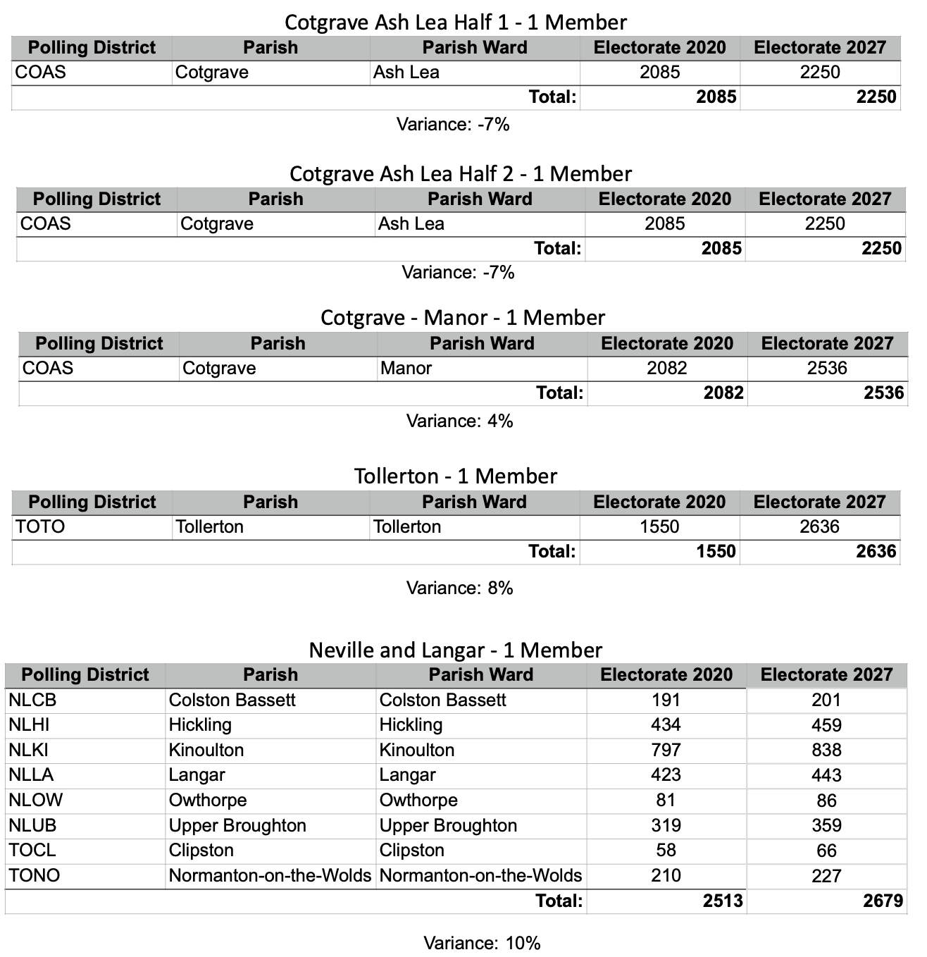
All wards sit within a plus or minus 10% variance using the 2027 Electorate.
Option 2:

Keep Ash Lea as a whole ward creating one two-member ward and 3 single member wards:
Ash Lea (2 Member)
Manor (1 Member)
Tollerton (1 Member)
Neville and Langar (1 Member)
All wards sit within a plus or minus 10% variance using the 2027 Electorate.
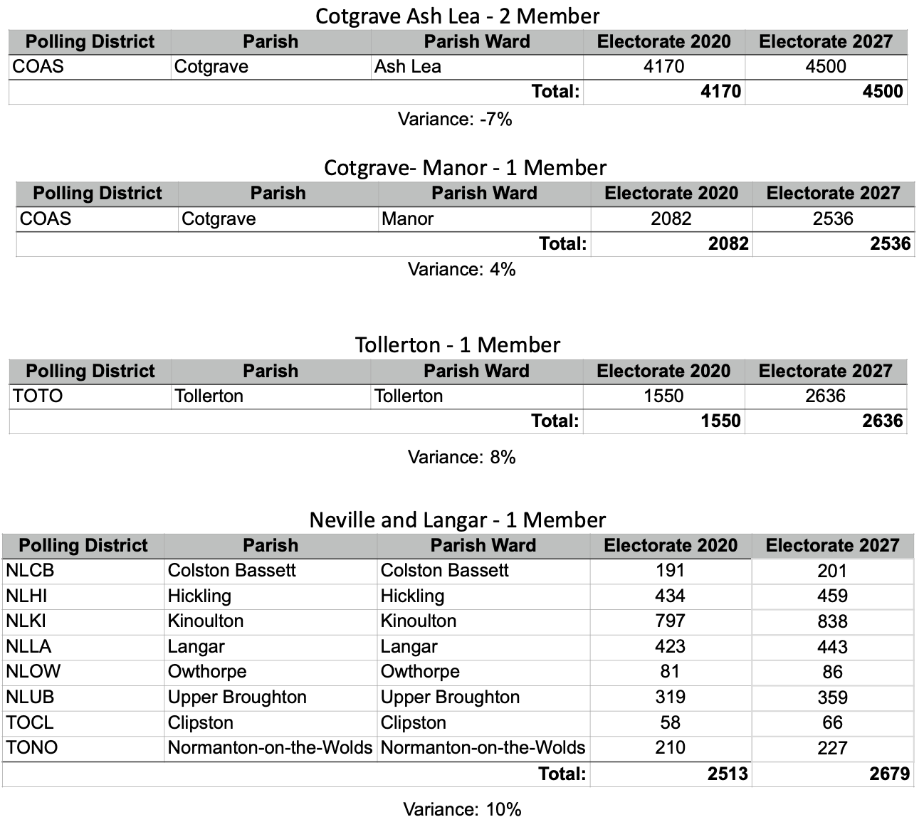

Option 3:
Retaining Cotgrave as 3 member ward (as per the current system) and create 2 new single member wards:
Cotgrave (3 Member)
Tollerton (1 Member)
Neville and Langar (1 Member)
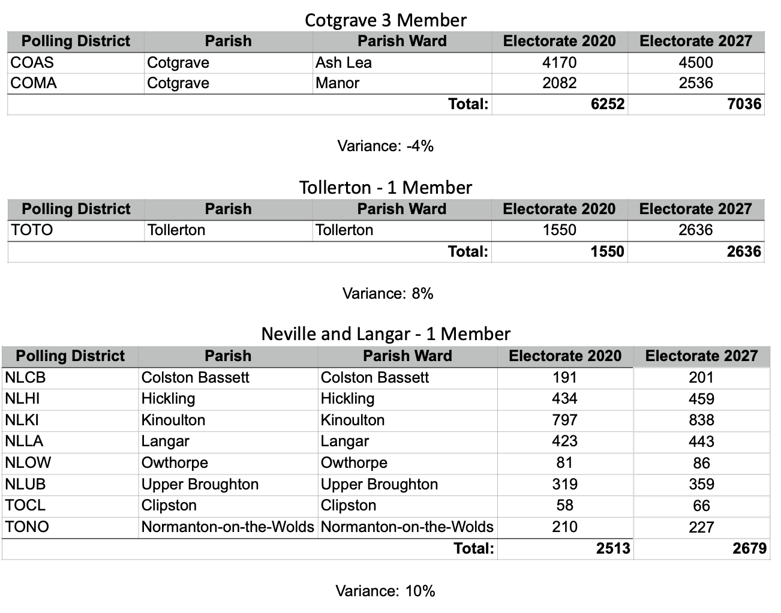
All wards sit within a plus or minus 10% variance using the 2027 Electorate.

